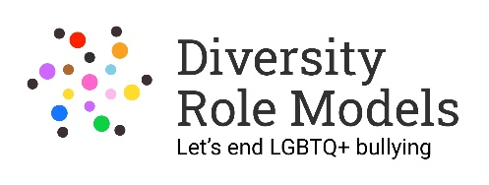 | Equal Opportunities  Monitoring Form

THIS FROM WILL BE DETACHED FROM YOUR APPLICATION AND WILL NOT BE SEEN BY THE SELECTION PANEL. IT WILL BE USED ONLY FOR MONITORING PURPOSES.

EQUAL OPPORTUNITIES MONITORING FORM

Diversity Role Models are committed to the Principle of Equal Opportunities and strive to be an Equal Opportunity Employer. To ensure that we comply with Equal Opportunity Legislation the organisation asks that all applicants complete the details below. This information will be used solely for monitoring purposes and will be treated as confidential; it will be separated from your application upon receipt and before any consideration of candidates takes place. Your application will not be affected by the information provided or if you choose not to complete part or all of this section.

Application for the post of:

Please state here where you saw the post advertised:

Your age range:

18-25 |  | 26-40 |  | 41-65 |  | 65+

How would you describe your gender?
Woman (including trans woman) |  | Man (including trans man) |  |  | Non-binary
Other – please state:

Is your gender identity the same as that you were assigned at birth? |  | Yes |  | No
(If your gender is not the same as the sex recorded on your birth certificate when you were born - for example, you are transgender or non-binary - tick “No”.)

How would you describe your sexual orientation?

Bisexual |  | Gay |  | Heterosexual |  |  | Lesbian |  | Queer
Other – please state:

Which category best describes your ethnic or cultural origin?

Asian |  | Mixed |  | White
Asian British |  | Asian & White |  | British
Bangladeshi |  | Black African & White |  | Irish
Indian |  | Black Caribbean & White |  | European
Pakistani |  | Other |  | Other
Other
Black |  | Chinese or Other Ethnic Group
Black British |  | Chinese |  | Gypsy
African |  | Arab |  | Traveller
Caribbean |  | Jewish |  | Other
Sudanese

If you have a religious or other belief how would you describe it?

Agnostic |  | Christian (incl. all denominations) |  |  | Jewish |  | Sikh
Atheist or no religion |  | Hindu |  |  | Muslim |  | Buddhist
Jain |  | Pagan
Other belief – please state:

Do you consider yourself to be a disabled person?
As set out in section 6 of the Equality Act 2010 (This may also include long-term medical conditions)

Yes |  | No

Do you have caring responsibilities? If yes, please tick all that apply

Primary carer of a child/children (under 18) |  | Primary carer of older person
Primary carer of disabled child/children |  | Secondary carer (another person carries out the main caring role)
Primary carer of disabled adult (18 and over) |  | None

Thank you for taking the time to complete this form.
This is separate from your application form and will not be seen by the shortlisting panel.

